1. **What do you mean by cells in an excel sheet?**

**Cell** is a **fundamental unit** within the **grid layout of a spreadsheet**. It **stores data such as numbers, text, dates, and formulas.** Cells are identified by a unique combination of column letters and row numbers, like "A1" .

We can enable calculations, house formulas, and can reference other cells. It also offers formatting options, can be merged, and allows data validation.

Cell are essential for organizing, analyzing, and visually representing data through charts and graphs.

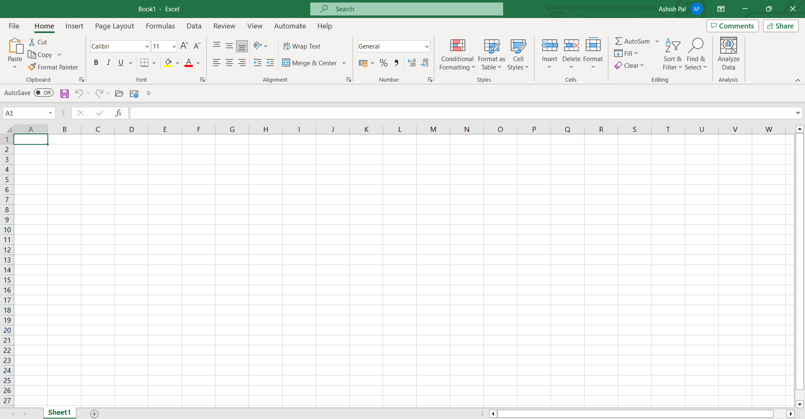

1. **How can you restrict someone from copying a cell from your worksheet?**

**Protect Specific Cells**

Select the cells > right-click>choose "Format Cells." >go to the "Protection" tab and check the "Locked" option. This will lock the selected cells.

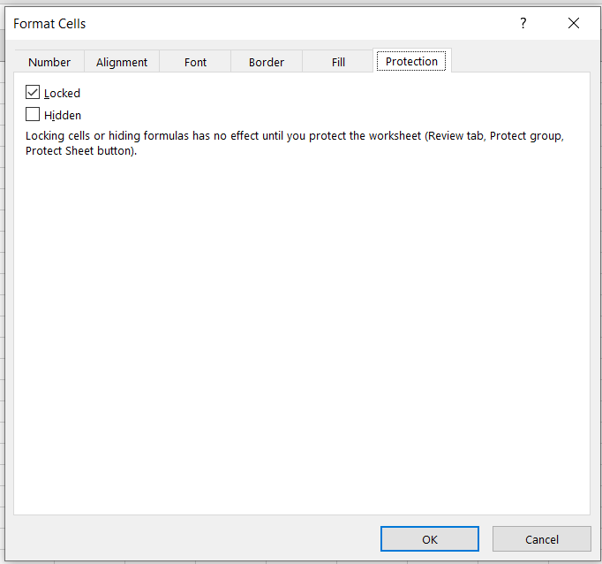

1. **How to move or copy the worksheet into another workbook?**
2. **Open both workbooks.**
3. **Right-click** on the source worksheet tab.
4. Choose **"Move or Copy."**
5. **Select the destination workbook.**
6. Choose where to place the moved sheet.
7. **Click "OK."** (in case of you want to Move only)
8. **Check “Create a Copy” and then Click "OK."** (in case you want to copy the workbook.)

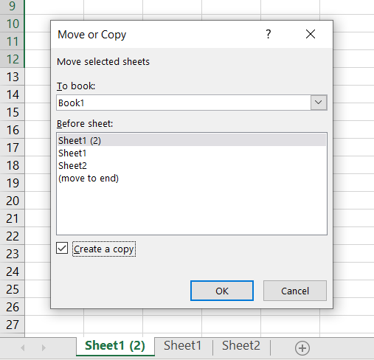

**4.Which key is used as a shortcut for opening a new window document?**

**Ctrl + N.** Pressing **Ctrl and N keys** simultaneously will usually create a new, blank document or window.

**5. What are the things that we can notice after opening the Excel interface?**

1. **The Ribbon**: A dynamic toolbar housing various tabs and commands.
2. **Quick Access Toolbar**: A personalized toolbar for frequently used functions.
3. **Worksheet Grid**: The main workspace for data entry and manipulation.
4. **Column and Row Headers**: Letters (A, B, ...) and numbers (1, 2, ...) for cell reference.
5. **Formula Bar**: Where cell contents are displayed and edited.
6. **Status Bar**: Offers insights and status indicators.
7. **Zoom Control**: Located in the bottom right for adjusting the view.
8. **Sheet Tabs**: Found at the bottom, facilitating easy worksheet switching.
9. **File Tab**: Opens the Backstage view for file-related actions.

**6. When to use a relative cell reference in excel?**

You use a relative cell reference in Excel when you want a formula or function to adapt as you copy it to different cells. It's useful for calculations across rows or columns, working with patterned data, repeating formulas, and simplifying repetitive tasks. Excel automatically adjusts the references based on the relative position of the formula when you copy it.

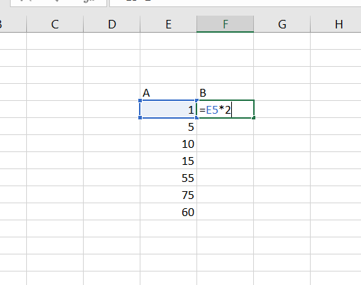

Here we made CELL E5 as reference cell and perform multiplication operation over it.

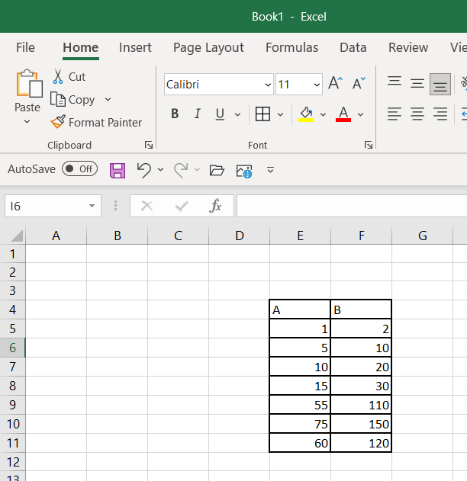Similarly, the same operation is being operate to F Column other cells respective to their E Column cells.